Section 1: Visualization Tool
Tableau: Reason for Choice
- Improved Visualizations: Tableau supports layered visualizations, thereby making it easier to visualize trends like innings-wise performance or venue-wise win percentage.
- Ease of Use: Drag-and-drop functionality facilitates ease and simplicity in creating complex dashboards.
- Customization: Provides very high flexibility to create custom tooltip and dashboard layout to offer an even more user-friendly experience.
- Storytelling: Supports "Story" feature that can lead users through match trends, strategies, and feature players.
Section 2: Data Pre-processing
Fields:
- Score
Problem: Stored as a string like "250/8" (runs/wickets).
Action: Extract the number before the slash ("/") — this is the team's runs. Convert it to a numeric (integer) type.
Reason: Needed for proper score analysis, aggregations, and comparisons.
- RPO (Runs Per Over)
Problem: Stored as a string (e.g., "5.6").
Action: Convert it from string to float.
Reason: To support mathematical operations like averaging and plotting RPO trends.

- Opposition
Problem: Has an unwanted "v " prefix (e.g., "v India").
Action: Remove the "v" prefix from team names to normalize them (e.g., "India").
Reason: Enable clean filtering, grouping, and comparison with Country field.
- Start Date
Problem: Was saved as text (e.g., "30 May 2019").
Action: Normalise it into a DateTime format (e.g., YYYY-MM-DD).
Reason: Required for time-series analysis like seasonality trends or date-based filters.
- Result
Problem: May have been in mixed cases (e.g., "Won", "won", "LOST") or null values.
Action: Standardize all entries (e.g., use lower case or title case throughout: "Won", "Lost", "Tied", "No Result"). Handle missing or blank values appropriately (e.g., mark as "No Result").
Reason: For accurate win-loss calculations and charts.

Section 3: Final Set of Questions
General Match & Team Performance Questions
- Which team won the most matches in the 2019 ICC World Cup?
- Which team had the highest average score across the tournament?
- Which team had the best win percentage during the tournament?
- Which venue hosted the most matches during the World Cup?
Location-Based Questions
- Which city or venue had the highest average match scores?
- Which venues were more favorable for chasing teams?
Match Strategy Questions
- How often did teams win when choosing to bat first vs field first?
- What was the average score in the first innings compared to the second innings?
- Which teams performed better while chasing targets instead of setting them?
- What was the success rate for teams defending targets above 300 runs?

Section 4:

1. Which team won the most matches?
Most Preferable Chart: Horizontal Bar Chart
Teams ranked by number of matches won. Easy to compare multiple teams’ side by side.
Pre-attentive Attributes:
- Bar length (longer = more wins)
- Color (highlight top team)
Colors:
- Normal teams = one color
- Top team = Different color
Rough Draft:
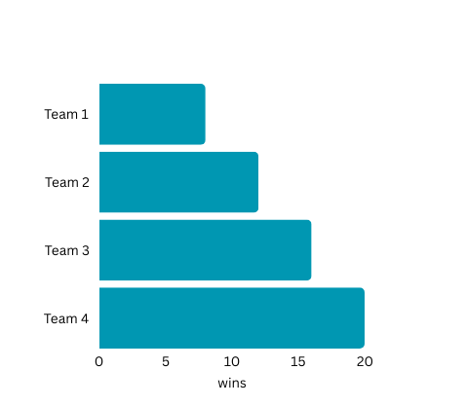

2. Which team had the highest average score?
Plot: Vertical Bar Chart (Teams on X-axis, Average Score on Y-axis)
What it shows: Displays batting strength based on average runs scored.
Pre-attentive Attributes:
  - Height (higher bar = better average)
  - Color
Colors:
  - Darker color for higher averages.
Rough Draft:

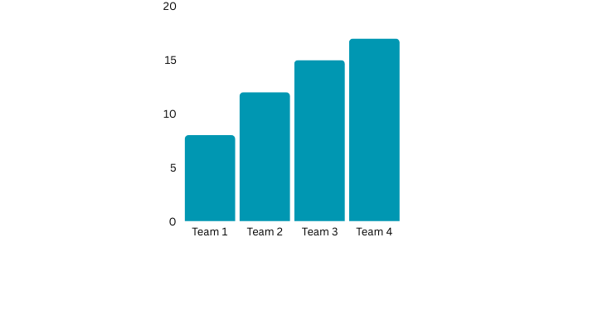

3. Which team had the best win percentage?
Plot: Donut Chart (Win % per team)
What it shows: Visualizes relative win success per team as a percentage.
Pre-attentive Attributes:
  - Area (pie slice size = win %)
  - Color (distinct colors per team)
Colors:
  - Unique bright colors per team.
Rough Draft:

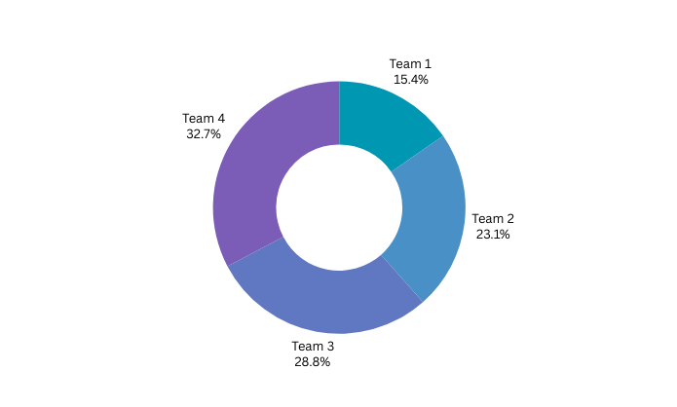

4. Which venue hosted the most matches?
Plot: Sorted Horizontal Bar Chart
What it shows: Tells which stadiums were the busiest.
Pre-attentive Attributes:
  - Height
  - Color
Colors:
  - Unique color for top venues.
Rough Draft:
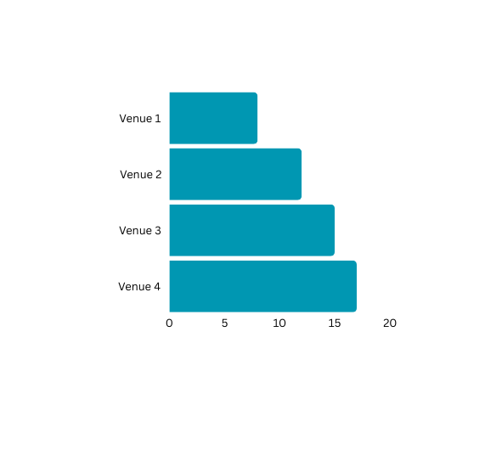

5. Which city or venue had the highest average match scores?
Plot: Scatter Plot (Ground vs Avg Score)
What it shows: Compares venues based on how "high scoring" they were.
Pre-attentive Attributes:
  - Position (height = average runs)
  - Size (optional: bigger dot = more matches)
Colors:
  - Blue dots
Rough Draft:


6. Which venues were more favorable for chasing teams?
Plot: Bar Chart (Venue vs Win by 1st vs 2nd innings)
What it shows: Shows winning trends at each ground based on innings.
Pre-attentive Attributes:
  - Length
  - Color
Colors:
  - Color1 = chasing wins
  - Color 2 = batting first wins
Rough Draft:

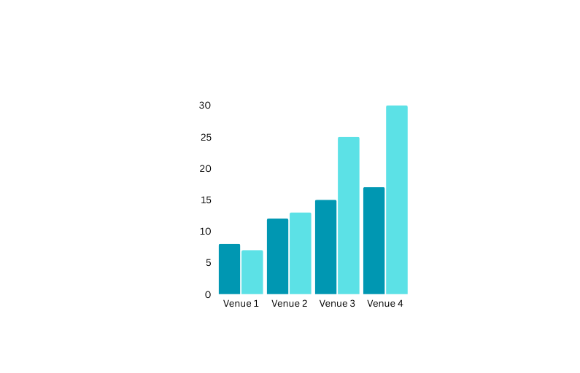

7. How often did teams win when choosing to bat first vs field first?
Plot: Grouped Bar Chart (Decision type vs Win/Loss)
What it shows: Strategic importance of toss decision.
Pre-attentive Attributes:
  - Height
  - Color (bat first = orange, field first = purple)
Colors:
  - Orange vs Purple
Rough Draft:

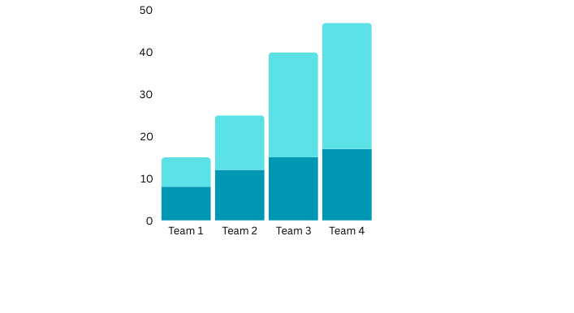

8. What was the average score in first innings vs second innings?
Plot: Side-by-side Bar Chart (Innings 1 vs Innings 2)
What it shows: Scoring pattern change between innings.
Pre-attentive Attributes:
  - Height
  - Color
Colors:
  - 1st innings = blue, 2nd innings = red
Rough Draft:
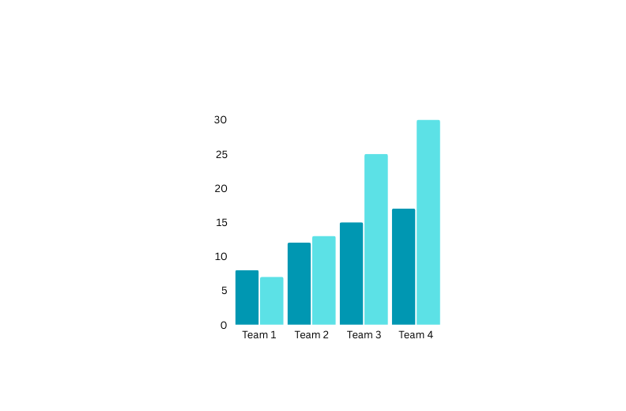

9. Which teams performed better while chasing targets?
Most Preferable Chart: Line Chart
Win % while chasing across teams. Trends clearly visible, quick team comparison.
Pre-attentive attributes:
  - Slope and Position
  - Shape (Circle)
Rough Draft:
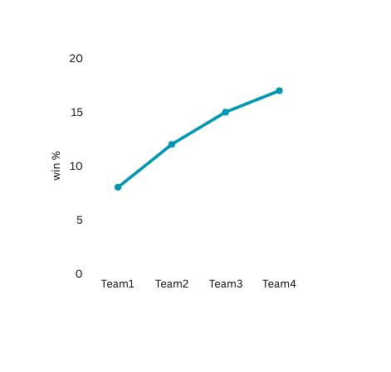

10. What was the success rate for teams defending targets above 300 runs?
Plot: Pie Chart (Successful Defense vs Failure)
What it shows: Teams' ability to defend big scores.
Pre-attentive Attributes:
  - Area
  - Color
Colors:
  - Dark Green = Successful defense
  - Light Red = Failed defense
Rough Draft:

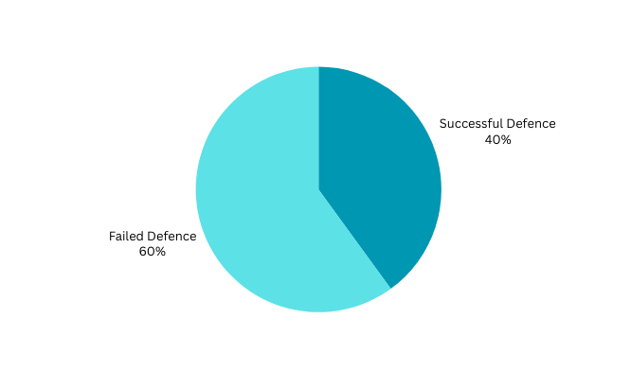

Section 5: Dashboard Interactivity
- Team Selector (Dropdown)
- Purpose:
To filter performance metrics like wins, average score, and win percentage by selected teams.
- Connected Plots:
  - Plot 1: Which team won the most matches?
  - Plot 2: Which team had the highest average score?
  - Plot 3: Which team had the best win percentage?
  - Plot 9: Which teams performed better while chasing targets?
- Value Range:
  - All team names from the Country attribute (e.g., India, Australia, England, etc.).
- Loaded from:
  - Country field.
Loaded from:
  - Ground field.
2. Venue Selector (Dropdown)
- Purpose:
To analyze match data specific to selected venues.
- Connected Plots:
  - Plot 4: Which venue hosted the most matches?
  - Plot 5: Which city or venue had the highest average match scores?
  - Plot 6: Which venues were more favorable for chasing teams?
- Value Range:
  - All stadium/ground names from the Ground attribute.
- Loaded from:
  - Ground field.
3. Innings Filter (Radio Buttons)
- Purpose:
To differentiate performance by innings (first innings vs second innings).
- Connected Plots:
  - Plot 7: How often did teams win when choosing to bat first vs field first?
  - Plot 8: What was the average score in the first innings compared to the second innings?
- Value Range:
  - 1 (first innings)
  - 2 (second innings)
- Loaded from:
  - Inns field.
4. Bat/Field Toss Decision Filter (Dropdown)
- Purpose:
To filter matches based on toss decisions — bat first or field first.
- Connected Plots:
  - Plot 7: How often did teams win when choosing to bat first vs field first?
- Value Range:
  - bat, field
- Loaded from:
  - Toss Decision field (or a derived attribute if needed from match logic — depends slightly on data cleaning).
5. Target Score Filter (Slider)
- Purpose:
To filter matches where the team had a target greater than 300 runs.
- Connected Plots:
  - Plot 10: What was the success rate for teams defending targets above 300 runs?
- Value Range:
  - 68 to 482 (based on Target attribute range).
- Loaded from:
  - Target field.
6. Result Filter (Dropdown)
- Purpose:
To filter based on match outcomes (won, lost, tied, no result).
- Connected Plots:
  - Plot 1: Which team won the most matches?
  - Plot 3: Which team had the best win percentage?
  - Plot 6: Which venues were more favorable for chasing teams?
  - Plot 7: How often did teams win when choosing to bat first vs field first?
  - Plot 9: Which teams performed better while chasing targets?
  - Plot 10: What was the success rate for teams defending targets above 300 runs?
- Value Range:
  - won, lost, tied, no result
- Loaded from:
  - Result field.

Section 6:
Mural Link:
https://app.mural.co/t/team133626/m/team133626/1744656745625/73ea577e98524dd9edb60a81f23e1ae5a9e44445?sender=u326fe82ee130dabcffbc7325

Reference link for Dataset:
https://www.kaggle.com/code/venky73/icc-cricket-world-cup-2019-analysis/input?select=ODI_Match_Totals.csv

